**Golf Club DB Walkthrough**

**1. Add Player**

**Description:** Admin must enter their **name,** **email, gender** and **handicap** to register a player.

**Steps:**

1. Open the Golf Club DB.
2. Tap **Register a Player** button or select **Player** menu.
3. Tap the **Create New** button.
4. Enter your **name,** **email, gender** and **handicap** in the respective fields.
5. Tap the **Create** button to proceed.

Figure Access player registration page

Figure Create new user button

Figure create player page

**Player Filter**

**Description:** Admin can filter players based on **gender, handicap** and **name**. Also, they can sort all grid columns.

**Steps:**

1. Open the Golf Club DB.
2. Tap **Register a Player** button or select **Player** menu.
3. Tap the **Create New** button.
4. Tap any column - **name,** **email, gender** and **handicap** to sort **asc** or **desc**.

Figure Ordered desc by membership number

1. Select the hamburger menu beside the **Name** column to apply the filters.

Figure Filter by player name

1. Select the hamburger menu beside the **Gender** column to filter by gender.

Figure Selecting Male gender

Figure Filtered by Male gender

1. Select the hamburger menu beside the **Handicap** column to filter the handicap range.

Figure Selecting handicap

Figure Selecting handicap below 10

**Edit Player**

**Description:** Admin can edit their **name,** **email, gender** and **handicap**.

**Steps:**

1. Open the Golf Club DB.
2. Tap **Register a Player** button or select **Player** menu.
3. Tap **edit** button.

Figure Edit player

Figure player edit page

**Player Details**

**Description:** Admin can check the register details and edit them through this page.

**Steps:**

1. Open the Golf Club DB.
2. Tap **Register a Player** button or select **Player** menu.
3. Tap **details** button.

Figure Detail button

Figure Detail Page

**Delete Player**

**Description:** Allow admins to delete registers

**Steps:**

1. Open the Golf Club DB.
2. Tap **Register a Player** button or select **Player** menu.
3. Tap **delete** button.

Figure Delete button

Figure Delete Page

**2. Add booking**

**Description:** Admin can booking a date for a Golf match based on the availability.

**Steps:**

1. Open the Golf Club DB.
2. Tap **Make a Booking** button or select **Booking** menu.
3. Tap the **Create New** button.
4. Enter the **Booked by,** **date, slot** and **players** in the respective fields.
5. Tap the **Book** button to proceed.

Figure Navigate to booking page

Figure Booking page highlighted Create new button

Figure Booking page

**Validation**

1. Admin must select the player that requested a book. The purpose of this field is to limit booking for the same player twice in the same day.

Figure Selecting booking player

1. The **Date** and **slot** are defined depending on the data based on these conditions:
   1. *Selected date* **<** *current date*: slot will be empty

Figure Slot empty validation

* 1. *Selected date* **>** *current date*: all slot available to select.

Figure All slots available

* 1. *Selected date* = *current date*: Only times later than the current time.

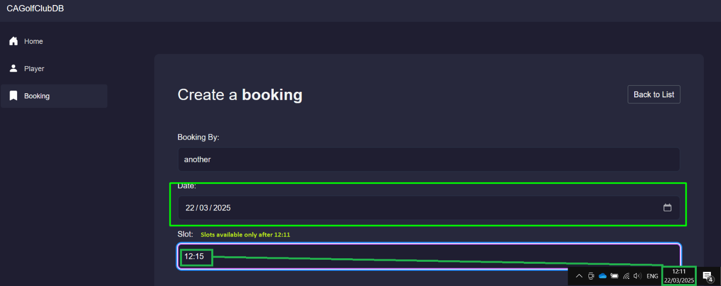

Figure Slots available only after 12:11

1. Admin can’t add more than 4 players for slot:

1. Players can’t be added twice:

1. Players can’t book a slot that was already booked:

